Query 1
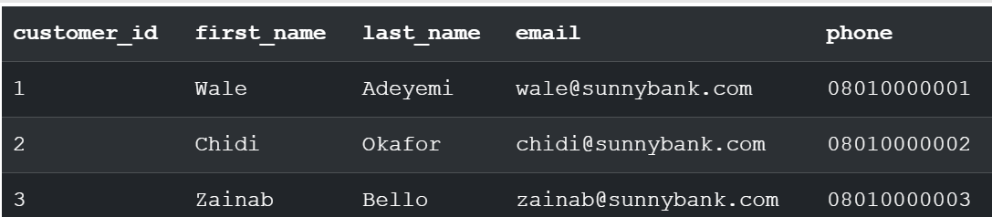

Query 2
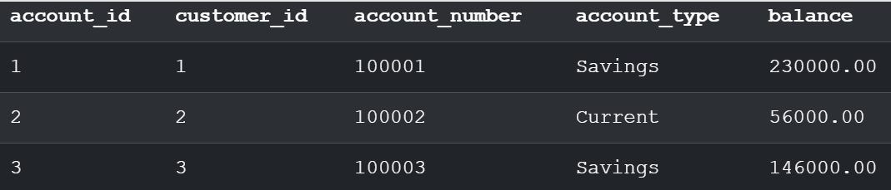

Query 3
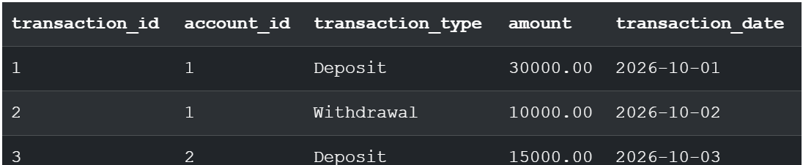


Query 4
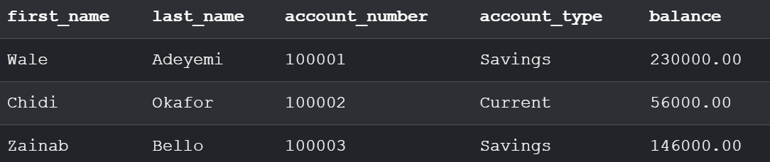
Query 5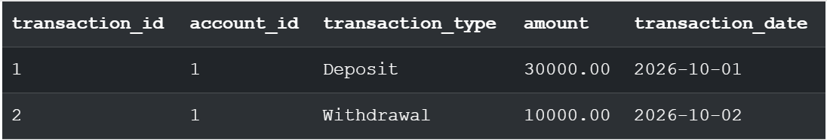

Query 6
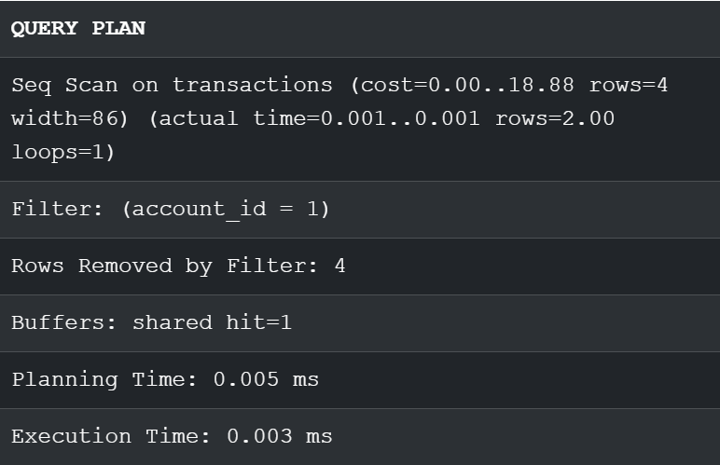

Query 7


